Derivadas de las funciones elementales

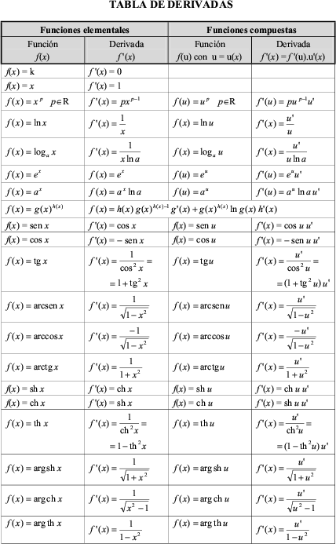
$$f(x)=\text{cot}g\underset{}{}x$$ | $$f´(x)=−\frac{1}{{\text{sen}}^{2}x}$$ | $$f(u)=\text{cot}g\underset{}{}u$$ | $$f´(u)=−\frac{1}{{\text{sen}}^{2}u}u´$$
$$f(x)=\text{sec}\underset{}{}x$$ | $$f´(x)=\text{sec}\underset{}{}x\text{.}\underset{}{}\text{tg}\underset{}{}x$$ | $$f(u)=\text{sec}\underset{}{}u$$ | $$f´(u)=\text{sec}\underset{}{}u\text{.}\underset{}{}\text{tg}\underset{}{}u\text{.}\underset{}{}u´$$
$$f(x)=\text{cos}\text{ec}\underset{}{}x$$ | $$f´(x)=−\text{cos}\text{ec}\underset{}{}x\text{.}\underset{}{}\text{cot}g\underset{}{}x$$ | $$f(u)=\text{cos}\text{ec}\underset{}{}u$$ | $$f´(u)=−\text{cos}\text{ec}\underset{}{}u\text{.}\underset{}{}\text{cot}g\underset{}{}u\text{.}\underset{}{}u´$$
$$f(x)=\text{arc}\underset{}{}\text{cot}g\underset{}{}x$$ | $$f´(x)=−\frac{1}{1+x^{2}}$$ | $$f(u)=\text{arc}\underset{}{}\text{cot}g\underset{}{}u$$ | $$f´(u)=−\frac{1}{1+u^{2}}\text{.}\underset{}{}u´$$

